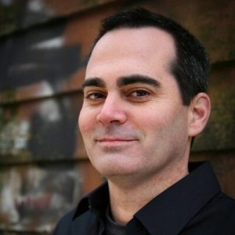

作者：Justin Holcomb（賈斯丁·霍爾寇姆）是聖公會牧師，任職於改革宗神學院（RTS）及戈登-康維爾神學院（GCTS）的神學教授。他著有《認識信條和會議》(Know the Creeds and Councils)、《認識異端邪說》(Know the Heretics)、以及《上帝的恩典》(On the Grace of God)等著作。賈斯丁還曾與妻子琳賽（Lindsey）合著《這是我的錯嗎？》(Is It My Fault?)、《擺脫我的恥辱：性侵犯受害者的希望與醫治》(Rid of My Disgrace: Hope and Healing for Victims of Sexual Assault)。

譯：DeepL；
校：JFX。
改革宗神學的兩個主要分支 2021-06-22
你聽過「另一種改革宗神學」嗎？對於改革宗的復興（Reformed resurgence）這一運動，許多人只知道改革宗神學在歷史中留下的廣泛影響力。可悲的是，由於約翰·加爾文的傳承不知不覺遭到了斷章取義，所以市面上有許多關於「加爾文主義」的片面理解。很多時候，改革宗神學被簡化爲了「加爾文主義五要點」：完全墮落、無條件揀選、有限的救贖、不可抗拒的恩典和聖徒的堅韌。雖然這種強調上帝如何拯救罪人的教導有其價值，但它未能在廣度上抓住改革宗神學傳承的全部。從約翰·加爾文的神學中發展出來的改革宗神學有兩個主要分支：蘇格蘭加爾文主義和荷蘭改革宗。蘇格蘭傳統非常注重救贖的教義和救贖秩序（ordo salutis），而荷蘭改革宗傳統更強調世界觀、文化參與以及耶穌在生活各方面的主宰地位。考慮到它們的共同來源，這兩個分支並沒有像你想像的那樣有衝突。因此，讓我們對蘇格蘭和荷蘭改革宗的神學傳統進行一次簡短的考察。

蘇格蘭傳統
在宗教改革早期，牧師-神學家約翰·諾克斯（1514-1572）是試圖改革蘇格蘭教會的某一團體成員。然而，他對宗教改革的參與導致了他的監禁和最終流亡。在流亡期間，他去了位於瑞士日內瓦的約翰·加爾文「行動基地」。在那裡，諾克斯迷上了預定和揀選的教義。他最終回國，成爲開創蘇格蘭教會的主要人物，蘇格蘭教會也是長老會的源頭。蘇格蘭改革宗神學傳統中的後幾代人（包括英國清教徒，如理查德·巴克斯特和約翰·歐文）因爲宣講可怕的地獄、嚴格執行教會紀律、深入教會成員的私人生活，以及壓制藝術而廣爲人知（事實上，這些認知並不完全公平）。美國神學家，如偉大的愛德華茲也受到蘇格蘭神學和哲學的影響，並同樣因此獲得了批評。每一種常見的批評可能都有一點道理，但很多做法是在獨特的文化環境中產生的，不應該成爲評判蘇格蘭改革宗神學的唯一標準。一些蘇格蘭改革宗神學後來走向了極端加爾文主義，但其最初的認信（比如1560年蘇格蘭信條）堅持了教會的宣教本質和神學的福音性重點。蘇格蘭改革宗的教義從未與實際生活分開。蘇格蘭神學家們最終以《威斯敏斯特信仰告白》作爲他們的教義標準（在聖經之下），並尋求將這些偉大的神學真理落實到他們的日常生活中。

荷蘭傳統
加爾文主義在1560年代宗教改革第三次浪潮中來到了荷蘭。荷蘭加爾文主義貢獻了一些最重要的早期改革宗信條和文件，例如1561年《比利時信條》（Belgic Confession）爲荷蘭改革宗教會提供了最初的規範，1563年的《海德堡教理問答》（Heidelberg Catechism）促進了荷蘭和德國改革宗之間的團結，1619年的《多特信條》（Canons of Dort ）成了一個改革宗大公會議的結論。隨著時間的推移，荷蘭改革宗教會漸漸陷入神學自由主義。然後，在19世紀末，新加爾文主義者，如亞伯拉罕·凱波爾（Abraham Kuyper）、赫爾曼·巴文克（Herman Bavinck）和路易斯·伯克富（Louis Berkhof）的工作塑造了現在被稱爲荷蘭改革宗的神學。雖然荷蘭改革宗的思想與更廣泛的改革宗傳統有許多共同之處，但有幾個特點使它與眾不同。道格拉斯·威爾遜（Douglas Wilson）的名言「全部生命屬於全部的基督」（"All of Christ for all of life"）和凱波爾的名言「整個宇宙沒有一寸土地不是耶穌指著宣告『這是我的』」，這兩句話是對荷蘭改革宗神學的最佳總結。凱波爾主張基督對所有生活的主宰權，並敦促基督徒不要把文化和社會的某些領域視爲「世俗的」。他認爲，上帝在不同的創造領域建立了權力結構，認識到這些領域之間的界限可以維持和平衡社會的正義和秩序。根據凱波爾的觀點，神在地上的治理是通過祂的教會在文化中的忠實存在而實現的。這一信念導致荷蘭神學家強調基督徒的文化行動。凱波爾希望基督徒們明白，每個世界觀都有獨特的哲學預設，而基督教的預設決定了信徒在生活的每個領域應該採取的行動。由於上帝的絕對主權，基督徒在生活的各個方面都能體驗到上帝的恩典，而不僅僅是在教會生活和敬拜上。荷蘭改革宗神學的高潮可以說是伯克富《系統神學》（悄悄告訴你：我第一次接觸改革宗神學就是17歲閱讀伯克富作品的時候）。荷蘭改革宗神學與美國的老普林斯頓神學（來自蘇格蘭加爾文主義傳統）有著重要的共同點，但他們在某些方面有很大不同。荷蘭改革宗認爲，人沒有宗教中立、「客觀的」理性能力。這意味著信徒和非信徒之間必然沒有共同點。這使得護教學更多是世界觀的衝突，而不是關於證據的辯論。

相互補充，而非相互矛盾
蘇格蘭改革宗與荷蘭改革宗在他們關注的焦點上似乎相差甚遠，但重要的是要注意到這兩個傳統發展時的明顯不同的文化環境。荷蘭神學家面對的是一個在19世紀屈服於現代主義和神學自由主義的教會，並試圖在他們在美洲大陸的新家園同時找到一個文化家園。因此，我們應該期待他們強調基督對當時的意識形態的最高統治，以及他們對文化的謹慎構想。在某種程度上，荷蘭改革派神學應用了宗教改革的廣泛原則，蘇格蘭改革宗則更注重宗教改革的主要教義，而不是將其具體應用於新的文化環境。此外，蘇格蘭改革宗將最初的宗教改革帶到了周邊地區，這也解釋了他們對宣教的重視。然而，即使在這些不同的關注點上，蘇格蘭和荷蘭改革宗的神學家們都注重使人成爲門徒，並將福音帶到他們周圍的世界。這兩個傳統都爲今天的改革宗復興運動提供了令人信服的範例。
https://tc.tgcchinese.org/article/two-major-streams-of-reformed-theology

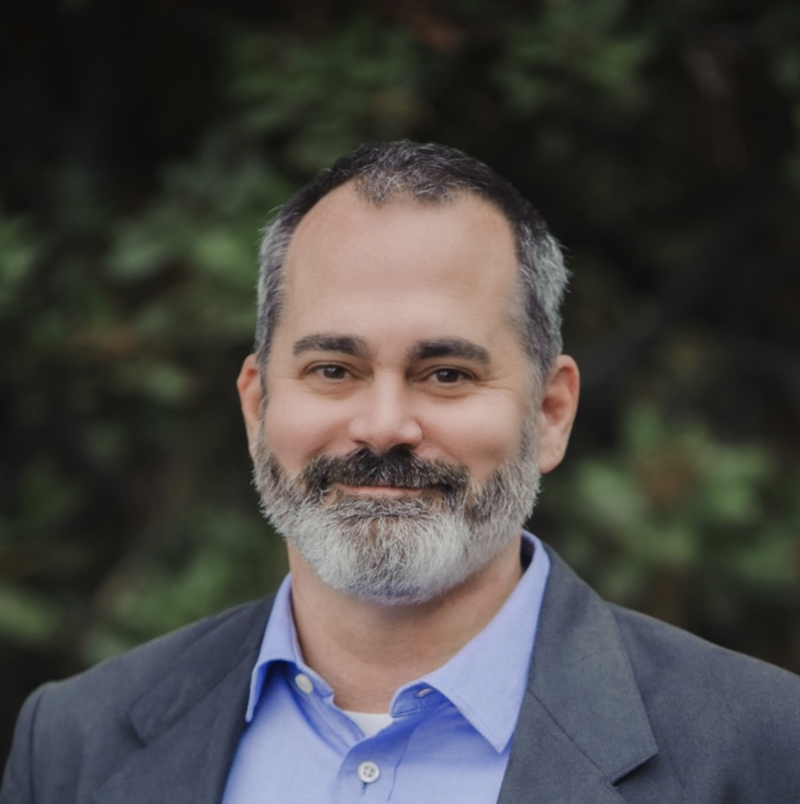
Justin Holcomb is an Episcopal priest and a theology professor at Reformed Theological Seminary and Gordon-Conwell Theological Seminary. He is author with his wife, Lindsey, of God Made All of Me, Is It My Fault?, and Rid of My Disgrace: Hope and Healing for Victims of Sexual Assault. Justin also has written or edited numerous other books on historical theology and biblical studies. You can find him on Facebook, Twitter, and at JustinHolcomb.com.

Two Major Streams of Reformed Theology
SEPTEMBER 24, 2012
Have you heard of the “other Reformed theology”? Many in the Reformed resurgence only know one aspect of the broad historical stream of Reformed theology, and sadly, many stereotypes of “Calvinism” exist because John Calvin’s legacy has been unknowingly truncated. Too often, Reformed theology is defined merely by the “five points of Calvinism”: total depravity, unconditional election, limited atonement, irresistible grace, and perseverance of the saints. While this emphasis on how God saves sinners has value, it fails to capture the full breadth of the heritage of Reformed thought. Two major streams of Reformed theology developed out of the work of John Calvin: the Scottish Calvinist stream and the Dutch Reformed stream. The Scottish tradition has a strong focus on doctrines of salvation and the ordo salutis (order of salvation). But the Dutch Reformed tradition also emphasizes worldviews, cultural engagement, and the lordship of Jesus over all aspects of life. The two streams have not converged as much as you might expect, considering their common source. So let’s take a short tour of the Scottish and Dutch Reformed theological traditions.

Scottish Tradition
In the early days of the Reformation, pastor-theologian John Knox (1514-1572) was part of a group trying to reform the Scottish church; his involvement, however, led to his imprisonment and eventual exile. While in exile, he traveled to John Calvin’s base of operations in Geneva, Switzerland. There Knox became enamored with the doctrine of predestination. Knox eventually returned and became the leading figure in founding the Church of Scotland, the origin of Presbyterianism. Subsequent generations within the Scottish Reformed theological tradition (including English Puritans such as Richard Baxter and John Owen) gained a reputation (not entirely fair) for being gloomy preachers of hell, for exercising harsh church discipline while delving into the private lives of church members, and for suppressing the arts. American theologians such as the great Jonathan Edwards were also influenced by Scottish theology and philosophy and inherited some of these same critiques. There may be a bit of truth in each of the common criticisms, but such practices arose out of unique cultural situations and should not be the only measures by which Scottish Reformed theology is judged. Some Scottish Reformed theology drifted into some heavier-handed forms of Calvinism, but its original confession (the Scots Confession of 1560) upheld the missional nature of the church and the evangelistic focus of theology. The Reformed doctrine of the Scots was never separated from practical living. The Scots looked to the Westminster Confession of Faith as their doctrinal standard (underneath Scripture) and sought to implement those great theological truths into their everyday lives.

Dutch Tradition
Calvinism arrived in the Netherlands in the third wave of the Reformation in the 1560s. Dutch Calvinism contributed some of the most important early Reformed creeds and confessions: the Belgic Confession of 1561 gave original definition to the Dutch Reformed Church; the Heidelberg Catechism of 1563 fostered unity between the Dutch and German Reformed; and the Canons of Dort in 1619 served as a Reformed ecumenical council. Over time the Dutch Reformed Church drifted into theological liberalism. Then, in the late 19th century, the work of Neo-Calvinists such as Abraham Kuyper, Herman Bavinck, and Louis Berkhof shaped what is now known as the Dutch Reformed school of theology (articles will eventually follow on each of these figures). While Dutch Reformed thought has much in common with the broader Reformed tradition, several features set it apart. Some of the best summaries of Dutch Reformed thought are captured in Douglas Wilson’s phrase, “All of Christ for all of life,” and in the famous words of Abraham Kuyper: “There is not a square inch in the whole domain of our human existence over which Christ, who is Sovereign over all, does not cry, ‘Mine!’” Kuyper argued for the lordship of Christ over all of life and urged Christians not to dismiss certain fields of culture and society as “worldly.” He believed that God established structures of authority in different spheres of creation, and recognizing the boundaries between these spheres maintains and balances justice and order in society. According to Kuyper, God’s rule on earth is brought about through the faithful cultural presence of his church. This belief led the Dutch theologians to emphasize cultural action on the part of Christians. Kuyper wanted Christians to understand that each worldview has unique philosophical assumptions, and that Christian assumptions shape the way believers should act in every area of life. As a result of God’s absolute sovereignty, Christians experience the grace of God in all aspects of life, not just in church activities and worship services. The high point of Dutch Reformed theology is arguably Louis Berkhof’s Systematic Theology (full disclosure: I first came to Reformed theology through reading Berkhof when I was 17). Dutch Reformed theology shared important essentials with the Old Princeton school of theology (from the Scottish Calvinist tradition) in the United States, but they differed significantly in some areas. The Dutch believed that people have no religiously neutral, “objective” rational faculty. This meant there was no common ground, necessarily, shared between believers and nonbelievers. This made apologetics more of a clash of worldviews than a debate over evidence.

Complementary, Not Contradictory
It may seem like the Scottish and Dutch streams of the Reformed church are miles apart in their emphases, but it is important to observe the significantly different cultural situations in which each of the traditions developed. The Dutch theologians faced a church giving in to modernist theological liberalism in the 19th century and tried to find a cultural home in their new settlements in the United States. As such, we should expect their emphases on the supreme reign of Christ over the ideologies of the day and their careful conception of culture. In a way, Dutch Reformed theology applied the broad principles of the Reformation. The Scots focused more on the primary doctrines of the Reformation than on their specific application to new cultural situations. Moreover, the Scottish Reformed took the initial Reformation to the surrounding regions, which explains their emphasis on missions. Nevertheless, even in these different points of focus, both the Scottish and Dutch Reformed theologians focused on making disciples and bringing the gospel to bear on the world around them. Both traditions offer compelling examples for the Reformed movement today.

https://www.thegospelcoalition.org/article/two-major-streams-of-reformed-theology/

